The Sheriffmuir – Archaeology, Land-Use and History
John G Harrison, March 2019
© John G Harrison, 2019.

Introduction
The place-name Sheriffmuir (sometimes Sheriff Muir) is not used consistently either historically or today. In this article it will mainly mean a fairly well-defined area, the former Commonty and some parts of the adjacent properties (focused around NN0383) around the Sheriffmuir Inn [Figure 1] (Adams, 1971, 189). But many of the sources use the name for almost any upland part of the parishes of Logie and Dunblane. A strict definition would exclude much of the designated area of the 1715 Battle of Sheriffmuir much of which was already farmland in 1715 in a way that most of the strictly-defined muir has never been (HES Inventory of Battlefields http://portal.historicenvironment.scot/designation/BTL17; Pollard, 2015; Inglis, 2005).
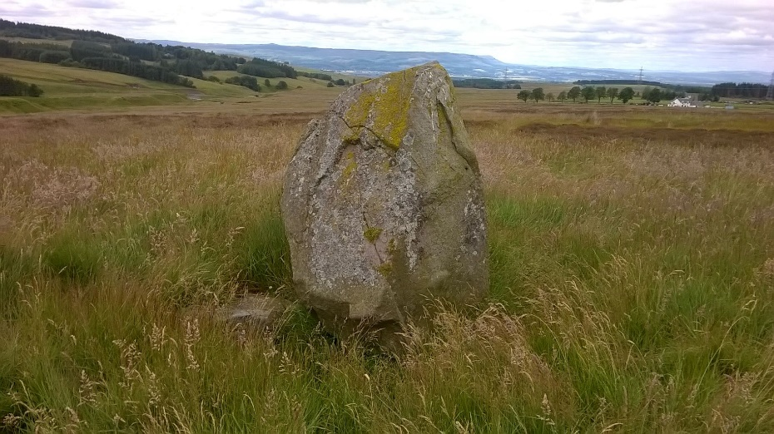
Figure 1 Core area of Sheriffmuir Commonty, standing stone in foreground, inn to right background (Photo, John G. Harrison).
It is not proposed to discuss the definition of moorland (Scots muir) except to point of that it has been extremely fluid. There is a general sense that it relates to rough land. Most often it applies to land above the head dyke, the wall dividing arable from enclosed ground from more open pasture. But the Burghmuir of Stirling has been arable for centuries; East Flanders Moss has many of the features of moorland but, like Burghmuir, is under 50m above sea level. Even upland moor is ecologically and economically variable, some with heather, some marshy, some grassy and so on. And, as muir is always understood to be poor, relatively-unproductive land, there have long been efforts to 'improve' it and put it to more productive use - so, as elsewhere, parts of the historical Sheriffmuir ceased to be muir 200 or 300 years ago. That transition from muir to enclosed land was paralleled by changes in ownership and tenure, particularly during the eighteenth century, the key period of this study. The former Commonty, which nowadays looks wild, even unkempt, was a site of intense activity in the past, its uses, appearance and ecology all being changed by human activity. Sheriffmuir, in fact, has experienced (and is experiencing) many processes which have influenced the appearance and ecology of all Scottish uplands. Figure 2, an area chosen almost at random, shows in an instant that many of the ecological boundaries have sharp (human-created) edges. As with other parts of the uplands, the story of the Sheriffmuir is very specific but it is also more general. At every stage it is linked to the economy and imperatives of the wider world.
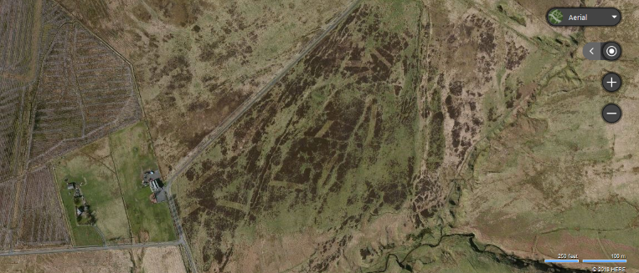
Figure 2 Aerial view of Sheriffmuir (inn towards left centre); sharp changes in vegetation indicate human impacts (Bing Aerial)

The deep past and the origins of the Sheriffmuir
An alignment of standing stones, prominently placed within the former Commonty, attests to past human interest in the area [Figure 1] The stones are likely to be of Neolithic or Bronze Age origin, indeed, one bears numerous cup marks (https://canmore.org.uk/site/25274/wallaces-stone). The tradition which names one of them The Wallace Stone and associates it with the Scots hero of the (1297) Battle of Stirling Bridge, surely has its origin in a line of Blind Harry's poem The Wallace. This was written in the later fifteenth century (almost 200 years after the events described) and contains as much myth as history. The poem has Wallace in Perth with his army;
Apon the morn till Schirreff Mur he raid
And thar a quhill in gud aray thai baid (McKim, Book 7).
Nowhere, contrary to some later accounts, does the poem claim that there was a battle at Sheriffmuir, rather, that the army paused there before advancing to what would become the victory of Stirling Bridge. The poem does imply that such a route from Perth to Stirling was practical (as it certainly was in later centuries) and it does provide an early record of the place-name Sheriffmuir - though, of course, dateable to the fifteenth not to the thirteenth century! The Standing Stones were mentioned witnesses as landmarks in the eighteenth century (see below) but not as related to Wallace. Given the popularity of the poem (three sixteenth century published editions and an English translation in the early eighteenth century) it is not surprising that this location should be identified with the hero, however unreliably. Several other standing stones in the area have been identified with battle sites - often on the slenderest of grounds.
In the seventeenth and eighteenth centuries, as shown by the detailed evidence to be discussed below, the Commonty was the common grazings for settlements stretching along the strath below, mainly to the north of Dunblane including Kippenross, Kippendavie and Kippenrait, Glassingallbeg, Kinbuck, Balhaldie, Cambushinnie, Feddal and Ardoch. By that time, these were mainly the properties of small lairds, the exception being Kinbuck which had been part of the much larger estate of the Earls of Perth, forfeited after 1745 (Wills, 1973, 15-17). It was mainly the livestock of the tenants of these lairds which grazed the Commonty and tenants, former tenants and herds were the main witnesses in the legal Process of Division of Commonty, to be discussed below.
This pattern of use in the seventeenth and eighteenth centuries supports the suggestion that the Commonty of Sheriffmuir could have originated as the common grazing of a medieval shire or thanage, based in Dunblane or Lecropt 'and perhaps equivalent to 'shire moor'' (Barrow, 1973, 268). That is further supported by the fact that most of these claimant farms can be shown to have been parts of the twelfth and thirteenth century earldom of Strathearn, many then incorporated into the later estate of Keir (which, itself, made no claim to Sheriffmuir) (Fraser, 1858, 211, 244-5, 264, 266, 298; RMS II entries, 2802, 3085; RMS III entry 1523; Neville, 2005, 49, 98, 114). However, it is striking that, whilst the southern ones were in Dunblane parish, sites such as Ardoch and Feddal were in medieval Muthil and Auchterarder, consonant with the earldom and the Commonty predating the (perhaps twelfth century) formation of the parishes (Watson, 2002, 394, 475).

The Commonty and its Division
The Commonty [Figure 4] was but a small part of the wider landscape of the western Ochils which include parts or all or the parishes of Logie, Alva, Tillicoultry, Dollar, Glendevon, Dunblane and Blackford. The Commonty lies between about 250m and 315m above sea level - well below the peaks (Ben Cleuch, 721m). In modern terms, the McRae Monument, the bridge over the Wharry Burn at Park and the fork in the road to Greenloaning are all, roughly, on the boundaries; the eastern limit is the River Burn, between the muir and Glentye Hill.
The varying terrain and the differing outcomes of the fragmentation of the medieval estates, resulted in a mosaic of different patterns of property types and tenure in the Ochils. By the seventeenth century. Glendevon, for example, was dominated by feuars (owner-occupiers) who were mainly resident and owned their own (substantial) farm stocks (Harrison, 1998). In Menstrie Glen, by contrast, most farms were small tenancies with only modest herds and flocks, whilst most of the landowners lived elsewhere, on the low ground (RCAHMS, 2001). Most of the lairds with claims to the Commonty of Sheriffmuir also lived on the lower parts of their estates, which stretched from the valley floor into the hills. A major use of the high hills before the seventeenth century had been shieling. In summer tenants' stock was taken to the high pastures, away from the arable; there, cheese and butter were made by herds who lived in specially-built huts. Such systems were in decline across the Lowlands by the seventeenth century. In Strathallan, the home area for stock pasturing the Commonty, so close to the Highland boundaries, the disruptions and raiding of seventeenth century warfare left the tenants so short of capital that they could not stock the shieling sites. This left the hills free for more commercial flocks, mainly from the south of the hills (Harrison, in press; Dixon, 2018).
However, since growing crops had still to be protected from stock in a largely-unenclosed landscape, abandonment of shieling may have increased pressure on the Commonty, especially once the tenants had re-capitalised. But the one was not a substitute for the other for, whilst stock would spend several weeks at the shieling grounds, stock taken to the Commonty in the morning returned home in the evening, a process to be discussed in more detail below.
Scottish commonties, in contrast to the English commons, belonged to the adjacent proprietors, though most rights were actually exercised by the tenants in (at least theoretical) proportion to the size of their tenancies and according to fairly well-recognised limits. All could use the whole area (though, for reasons of convenience, they might rarely use parts remote from their own lands). Proprietors had probably always been free to divide a commonty if all were in agreement but this was facilitated by legislation in1695. All claimants had to prove that they had legal title (Adams, 1971, vii-xii) though, regrettably, in this case, the title documents produced were all quite recent, not more than a few decades before the main process in the early 1770s.
A complication, in the case of the Sheriffmuir, is that it lay on the road from the Highlands to the Lowland markets, providing the last option for hill grazing en route to the great eighteenth and nineteenth century tryst at Falkirk (Haldane, 1973,113). By about the 1680s (the period when this trade was increasing, driven largely by demand for beef in England) payment was being exacted for grazing leased to passing drovers (NRS CS25/1772/12/2, Process p. 221-2, p 217-8) By the 1770s there was a tryst or cattle market held on the muir, close to the Standing Stones (Process, p. 70-1). This was to become a regular event. In 1850-1 it was proposed that the main tryst at Falkirk should be moved to the Sheriffmuir, a proposal supported by assertions that there was adequate pasture for the (huge) numbers of stock involved (Scotsman, 25 Sept 1850 p. 3; Dundee Courier, 7 May 1851). In 1858 it was reported that a thousand beasts had been sold at Sheriffmuir, enough to impact on the tryst at Falkirk (Dundee Courier, 13 Oct 1858). The Sheriffmuir tryst was still being advertised so late as 1881 (Aberdeen Weekly Journal, 24 Sept 1881). Clearly, large numbers of driven cattle would reduce the pasture available for local stock and landlords may have been tempted to favour the droves over their own tenants. Throughout its length the Sheriffmuir Road (like other drove roads) has had wide margins to allow for some pasture. In some sections (eg above the Inn) there are signs of older walls, beyond the modern fences whilst other sections have no modern fence [Figure 3].
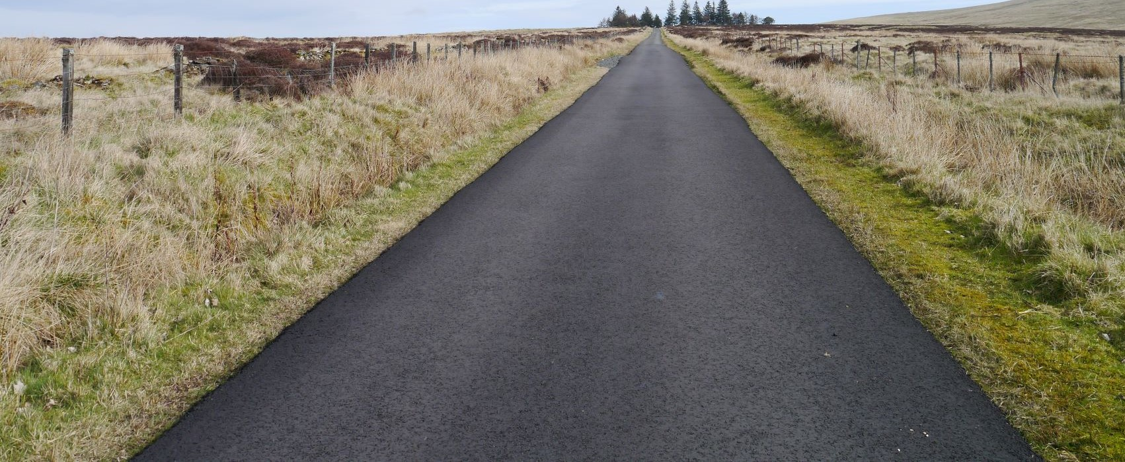
Figure 3 Road above the Inn, with wide margins and older wall beyond fence (Photo JGH)
It is unfortunate that little is known about the history of the roads. The major route is between two significantly-named locations, Greenloaning and Pathfoot (beside Stirling University Campus) though neither name can be shown to be older than the eighteenth century. The road ('the Sheriff Gate') and the bridge at Park are mentioned by witnesses and shown on the Plan of 1766 [Figure 4]. The lower section of the route to Dunblane (from the T junction near the modern Sheriffmuir Inn) was realigned sometime between 1766 and 1817 (Pollard, 134). Robert Menzies was licensee of the 'Sheriffmuirhouse' (evidently a precursor of the modern inn) in 1831 (Barty, 1944, 225). An unlabelled settlement is shown on the First Edition Ordnance Survey map, the inn is labelled on the Second Edition OS in the 1890s. The location of the inn at the junction is clearly significant for the routes as well as the trysts. The inn is, surely, a successor to an earlier inn at Bogs, at another junction, at the head of Menstrie Glen down the road towards Stirling (NS 81856 99875) (Monteath, 1887, 96-8).
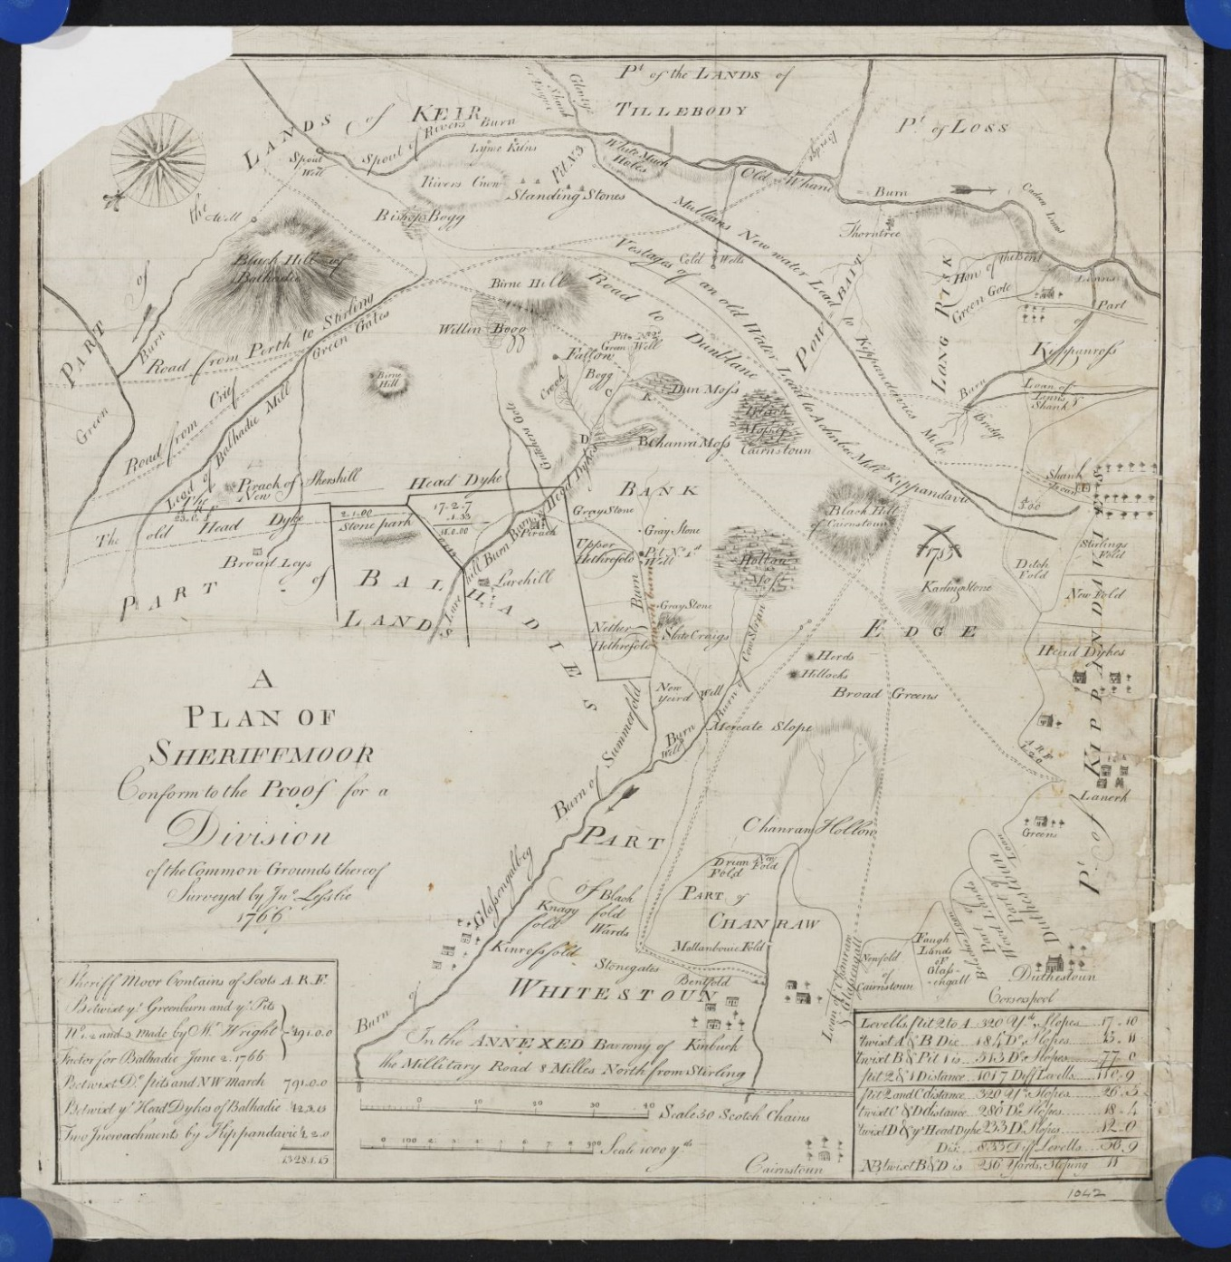
Figure 4 Plan of Commonty of Sheriffmuir (1766) (National Records of Scotland, RHP 1042).
The key evidence for the Commonty is provided by a case heard by the Court of Session in 1772. The record includes detailed statements by witnesses between 1766 and 1771 but documents from earlier disputes were also produced, particularly an earlier attempt at division in 1723-5 (with further witness statements) and notes of an agreement about a water lead and the boundaries of the muir in 1587 (NRS CS25/1772/12/2). A Plan of the Sheriffmuir, identifying many of the locations mentioned by the witnesses, was drawn by John Leslie in 1766 (NRS RHP1042). Together, these sources paint a vivid picture of the muir, today a rather empty and barren landscape, as an area full of people, activity and change. Over 40 named features are identified. One elderly witness in the 1720s recalled the muir in his childhood, in the mid seventeenth century. Others stress how pressures on the muir were increasing in the mid eighteenth century, how it was affected by wider change.
Shares of the property of the Commonty were allocated in proportion to the valuation of the claimants' estates (demonstrated by their legal title). But they also had to demonstrate use, whilst rivals often tried to demonstrate that they had disputed that usage, perhaps driven pasturing stock off or imposed limits on the peat cutting. A particularly strong counter-claim was to demonstrate that a part of the area was already 'private property', perhaps enclosed, certainly used exclusively by one claimant or their tenants. As in other cases, there were many complex issues and a simple geographical division was not always appropriate. It had been agreed before the case went to the Court of Session that Kippenross would continue to have use of a water lead which traversed land likely to be allocated to others. Similarly, it was agreed that areas where peat was cut might have to remain as commonty, at least for that purpose, if not for pasture.
John Faichney recalled the new head dyke of Balhaldie being built about 1743; some of the newly enclosed land was still heather or grass but parts were ploughed and sown with grain (CS25/1772/12/2, Process, p. 50-1). So, it was property and taken out of the process. Patrick Whitehead said that since his first recollections (probably before 1710) the estate of Kippendavie had been re-organised into new farms, those of Stanehill, Bourtreefauld, Shandraw and Dykedale (p. 86-92). John Wilson recalled part of the muir being enclosed about 1720 for Cauldronlinns (modern Linns) and about two acres for Shank, despite protests by other lairds (Process, p. 96-100). James Scobie (Process, p. 171-3) also described this two acres at Shank, how the head dykes had been advanced in stages and the ground improved 'by being tathed and watered ... and by being pastured for several years' so that it was 'much bettered' but still not worth the effort of ploughing. Two acres taken in at Muirhead Park of Kippendavie were 'bad and would scarcely have pastured two ewes’, being as bad as the muir contiguous (John Whitehead, Process, p. 173-180). The laird of Balhaldie, despite objections from others, had taken in stock belonging to others, excusing it as a 'one off' process known as tathing, as the manure would improve his enclosed ground - that is, they would pasture on the muir during the day but drop their dung on the enclosure at night and so enrich it. There were many similar recollections and description of the methods used to improve muirland, at least to improve the pasture. This expansion of the laboured land, part of a much wider process, was to reach its zenith in Scotland during the Napoleonic Wars, when high grain prices made marginal settlements viable, albeit many were to collapse by the 1820s as prices fell again (Atkinson, et al., 2016; Harrison, in press).
So, the muir was not isolated from adjacent areas nor from the wider world and its economic and social influences. Michael Stirling (Process p. 157-160) did not now send so many cattle to the muir as formerly because 'the grass was oppressed with too many'; several other witnesses recognised this over-grazing and the disputes about pasture are, themselves, symptomatic of increasing pressures. Indeed, it was these wider pressures which drove the process of division of the commonty.

Exploiting the Resources
John Buchanan (Process p. 43-50) makes clear that the herds on the muir were both male and female but all the witnesses were adult men, some recalling events from their own childhoods, decades earlier. Herding was the activity they most commonly describe. Malcolm McKendrick started to herd his father's lambs when he was about nine years old and afterwards the cattle, for several years until 'he was able to work at greater labour' '(Process, p. 25-30). Many other children started at similar ages, either working for their own families or others.
Most use of the muir was in the summer. There seems to have been a conventional stock subdivided between the units of each estate in proportion to their numbers of ploughs. Milk cattle were herded separately on the low ground so it was mainly young stock, dry cows, sheep and some horses which local farms sent to the muir, probably only a few days per week, so they were not totally dependent on it. And, of course, the stock would pasture on the way up and down, along well-recognised routes leading out onto the muir above their own had dykes. Once high enough to preclude their straying back, onto the arable, the herds might leave their charges and go off to play or socialise or go home for dinner, returning only later in the day.
William Adie was one of several to say that he thought he could have pastured further east than he did but he did what was 'most convenient’ (Process, p.74-5, William Adie). But, if that became an invariable rule, lairds knew that they were renouncing any claim to other, more remote parts of the commonty. So, sometimes they would instruct their herds to challenge their neighbours. This might involve driving stock a substantial distance, stock from Kinbuck taken to pasture about the Standing Stones, for example (Process, p. 70-1 Peter Buchanan). The lairds of Balhaldie were particularly determined to claim parts of the muir as their property and periodically instructed their herds to drive rivals off. Several men recalled that, perhaps about 1730, Balhaldie had employed a young man called Robert McGregor (sometimes called Captain Caldwell) 'who wore a dirk and was a terror to all the herds about him, for he was a strong man' (Process, p. 63-67 William Caiden). John Williamson had seen the other herds run away when MacGregor appeared for he was 'a sturdy, thick young man, near to a man's age'; but Williamson agreed, that though often in his company, he had never seen the dirk (Process, p. 180-182 John Williamson). In reality, though legally important, such events were rare and Williamson (who lived at Glentye, overlooking the muir) had seen Balhaldie and Glassingallbeg tenants turn back Whitestone and Kinbuck tenants - but that had been eight or nine years ago!

Peat
Peat (and, to a lesser extent, also turf) are frequently mentioned. It was agreed between the parties in 1767 that the property of the mosses was to be divided if that was conveniently possible but, if not, they might be left in commonty, with rights of access secured. The first record of tension is from 1670 when the proprietor of Glassingallbeg agreed that, for the future, neither he nor his tenants would cut peats in the 'common moss', though they had done so previously; in practice, they still cut peats in the eighteenth century. In the 1760s, 81 year old Patrick Whitehead recalled that, when he was aged 14, 'the Dun-Moss in particular was parcelled out like Corn-ridges among the several tenants concerned' (Process, p. 86-92). In 1723 John Dow noted that, about 1710, the Din Moss failed (Process, p. 246-8) James McKendrick, speaking in the 1760s, thought that the Din Moss had, in fact, been burned sometime after 1715 (Process, p. 19-25). John Finlayson (Process, p. 100-108) said that the failure of the Din Moss and Shanraw Mosses had precipitated a series of disputes when a new allocation of rights had been agreed, a change also recognised by John Kinross (Process, p. 32-37) saying that the tenants from the west side now cut peats further east though the fuel was then sometimes taken off by their rivals. James McKendrick (Process, p. 19-25) recalled a time when the laird of Kippendavie came up with some tenants and cut peat and turves, well to the east, so Balhaldie also came up and challenged him, and said 'it was a small matter but upon his ground ' and the two lairds went to dine together at Balhaldie's house at Lairhill and Kippendavie carried off the turves. John Ritchie (Process, p. 125-127) was cutting peats in the Bishop's Bog when 'the young laird of Balhaldie came past without challenging him and gave him a snuff'; he said that in the 1760s, the tenants of Kippenross and Kippendavie still cut peats in the muir for their houses but paid to get peats in Glentye for drying corn as they were better for that. James Drummond had been told by his father that Balhaldie and his tenants sometimes cut peats to the west and 'Balhaldy himself had cut them as fast as any' (Process, p. 37-43). But the most telling comment was by John Pearson, from Kippenross, aged 70. Till about 1750 he had constantly cut his peats in the muir, sometimes in the Willow Bog, the Bishop's Bog or Birniehill. But since then 'he has not made use of peats but of Coals for his family' (Process, p. 127-8). So, again, the outer world was impacting on the muir - as mining technology and road transport both improved, coal became cheaper and easier to obtain than 'free' peat which involved so much hard work.
Turf (used for building as well as fuel) heather and rushes (for thatch) could be found in many parts of the muir. Many witnesses mention them and from time to time they were seized and carried off by rivals. But these disputes seem, usually, to be proxies for disputes about pasture or peat. That was probably also the case with disputes about water.

Water
A water lead is mentioned as early as the 1570s and in the 1760s all the claimants had agreed that Kippendavie had right to a water lead across the commonty to his property lands; this was to be a servitude on the heritors of the moor along its present course. The Plan shows an old course as well as the current one in which water still flows in 2019 (Canmore ID 25272; RHP1042; Figure 4, Figure 5). Many witnesses mention this feature, all agreeing that it served the lands and the mansion house of Kippendavie, several also emphasising it was used for 'watering' the land, a distinctive Scots form of improvement, particularly applied where land was being newly brought into cultivation (Harrison, 2012). However, the primary purpose had been to supply a mill at Auchinbae. That mill had undergone various changes of use and, perhaps about 1740, had been abandoned, though the estate continued to use the lead (perhaps now diverted to its new route) for the other purposes (James Scobie, Process, p. 171-173; John Whitehead, Process, p. 173-180, James Balcanqual, Process, p. 229-230). Patrick Whitehead recalled maintaining it, back to about the mid seventeenth century (Process, p. 86-92).
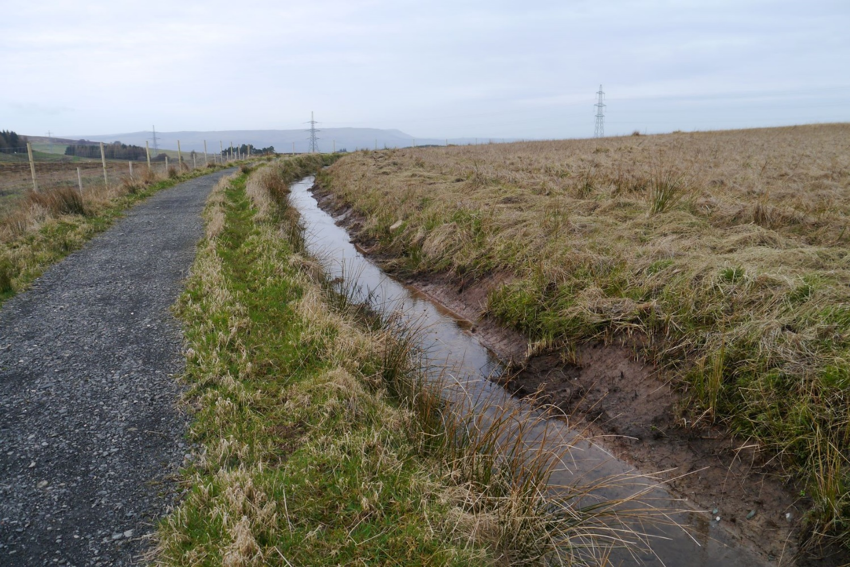
Figure 5 This lead had already replaced the older one by the mid eighteenth century (Photo John G Harrison)
Balhaldie also claimed right to take water from the Spout of the River Burn to his lands, perhaps for similar uses. Though this might be hinted at on the Plan, John Finlayson was probably right to be sceptical if water could have flowed on such a route (Process, p. 100-108 John Finlayson). But several people attest to its existence - and impossible claims are not unknown in such cases! James McKendrick claimed to have had it pointed out to him by the laird of Balhaldie before 1715 (Process, p. 19-25). Peter Monteith had also seen it (Process, p. 51-53) and said that, when he was the miller at Auchinbae, he had cut Balhaldie's lead as his own water was short. John Monteith had seen this happen about the 1720s (Process, p. 155-7). John Whitehead said that the Kippendavie people regularly dammed up any lead to Balhaldie and made all the water run their way (Process, p. 173-180). Certainly, if water supply was an issue (in a drought, for example) then any lead to Balhaldie would compete with Kippendavie's claims.

Lime
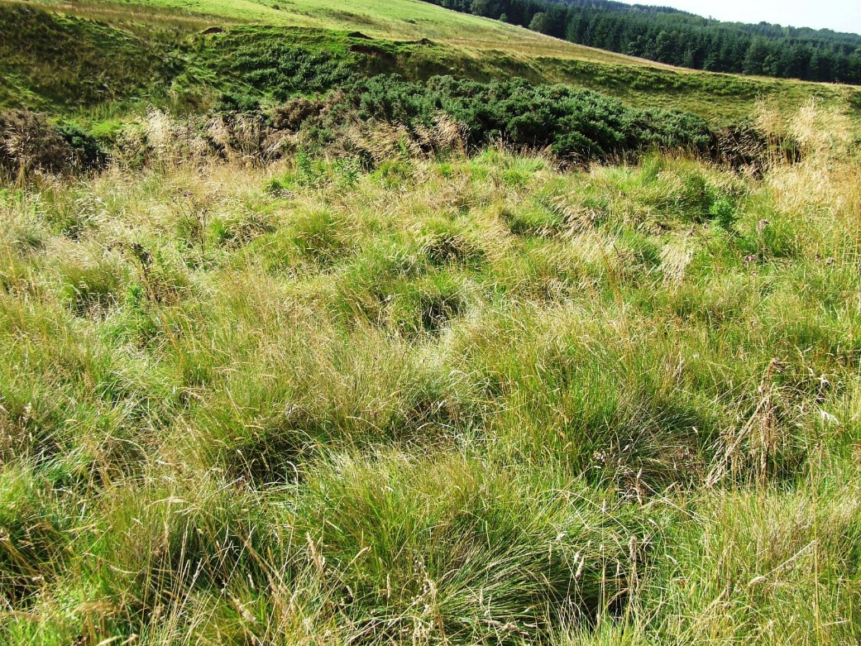
Figure 6 Greener than its surroundings, the site of a former lime kiln beside Auld Wharry Burn (photo John G Harrison)
Finally, lime was quarried and burned (for agricultural use) along the Auld Wharry Burn and up towards the Spout of the River Burn as marked on the Plan. There are archaeological remains of lime kilns and a distinctive flora on the lime-rich sites [Figure 6]. This was not carboniferous limestone but cornstone, a calciferous sandstone, of poor quality but widely used where better lime was not available (RHP1042; Canmore Website ID 25273; Mitchell, 1997, 3-5). Unlike the other resources, which had been used since time immemorial and were mainly widely distributed across the commonty, cornstone outcrops were probably quite small and had only recently come into use in the 1720s. John Finlayson could not be positive how long ago it was since the tenants of Kinbuck began to work it 'but that it was several years before the Chase of Sheriffmuir' (ie the battle of 1715). John Reid, also in the 1720s, thought Balhaldie had won and burned lime as much as 30 years before and he had done so himself for 16 years (Process, p. 137-148). Alexander Wingate (Process, p. 122-124) said that about the 1730s, as a tenant of Glassingall, he won limestone 'yearly' and 'sometimes two kilns’ in a year; others also used the lime without challenge. Wingate also got some limestone along the Old Wharry Burn but made little use of it, as it was not good. John Kinross (Process, p. 32-7) agreed with him that when people from Loss and Pendreich tried to use this resource, they were driven off by Balhaldie; they had no other claim to the commonty, though they might have worked deposits on the opposite (left) bank of the stream, their own land.

Discussion of the Issues in the Division
The livestock fed along their daily route but returned to the home ground in the evening, where much of the dung would be dropped. Peat, rushes and heather would all, eventually, via fire or dunghill, end up on the fields. Water might seem an improbable fertiliser but was certainly seen as such whilst use of lime was a 'new technology', a valuable input helping to release nutrients otherwise locked up and unavailable to the crop plants. So, the muir represents a source of inputs, a trickle of plant nutrients from the margins to the core areas of the farms. But that is countered by its use for droves, arriving from further north and (quite quickly) moving on south, so, they took nutrients out of the area but brought cash in.
For much of the time, there was no real dispute about marches and boundaries. As Malcolm KcKendrick said (Process, p. 25-30) the herds would play and leave the cattle to wander, only gathering them again when it was time to go home. James McKendrick makes clear that incidents and disputes were, in fact, rare - it was years before that Balhaldie and his tenants had driven back the Kinbuck tenants over the alleged march (Process, p. 19-25) or that Balhaldie had employed the young Highlander with his (perhaps imaginary) dirk. Landlords might point out these lines to the tenants and tell them to observe them and drive others off - but then relaxed and offered a snuff to someone blatantly transgressing their own rules. They were more concerned to protect their property rights than the actual resources which, as Balhaldie had said, were 'no great matter' but it was his ground.
Encroachments onto the muir by new enclosures were not large in the 1760s. Indeed, land which would 'not keep two ewes' and was little better than the adjacent muir, was not worth a lot of effort and expense. But they were symptomatic of change. By the 1760s, several decades of gradual change and innovation in Scottish farming were leading to a new optimism, encouraged by rising prices and technical innovations; landowners must have had a sense that 'anything might happen' in the not too distant future and it was safer to assert a claim than to let if fall into abeyance. Indeed, there were to be some substantial encroachments after the 1760s onto land which had previously been commonty and new uses which could have been impractical if the land had remained in commonty (see below). But not all change increased the pressures. As coal became more available, it would eventually render peat cutting redundant whilst other changes provided cheaper sources of better-quality lime than came from the muir. On the other hand, an increasingly commercial world would soon be moving even more cattle through the area further reducing the value of the former Commonty for local stock about which at least some of the witnesses were already sceptical.

Later Encroachments
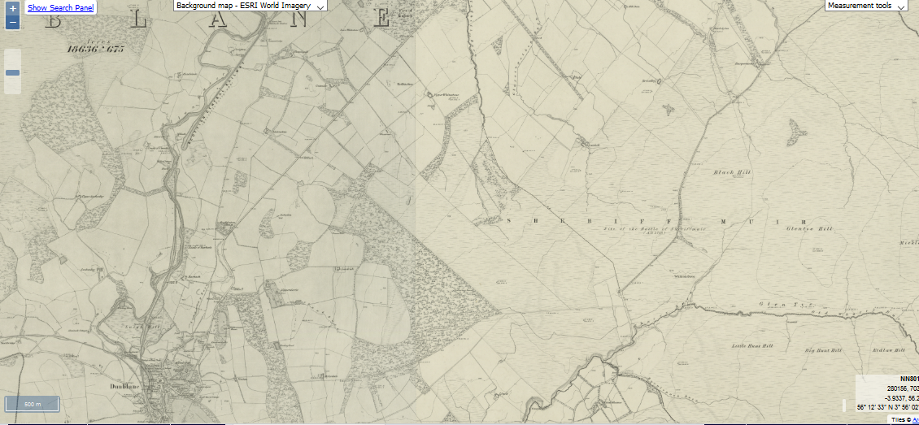
Figure 7 Extract first edition Ordnance Survey map (courtesy, National Library of Scotland).
By the time of the 1st Edition Ordnance Survey [Figure 7] the most obvious encroachment is extensive woodland, from above the farm of Dykedale to the vicinity of the modern McRae Monument, bounded for much of its length on the south by the 'Old Road' to Dunblane, the one seen on the 1766 plan. That road had been replaced by the modern line (past Kippenross Home Farm and Stonehill Farm) by 1817 (Pollard, 2015, 134).
Even below the farm of Linns, the 1st Edition shows some undrained, comparatively unimproved fields; above that is predominantly moorland though there are drained fields about the house (now the Sheriffmuir Inn) and so down the roadside to the Old Wharry Burn. There were two small areas of woodland, towards the north of the former Commonty, one west of the road, one east. But Broadleys and Lairhill are still just below the head dyke, as they had been in 1766 and there has certainly not been any general advance. None of the peat bogs, such a feature of 1766, are mapped - but they would not need to be distinguished from their surroundings of (often wettish) poor ground for this purpose.
By the second edition Ordnance Survey there is a great deal more woodland, much of it mixed and including the large Sheriffmuir Big Wood, west of the (still to be erected) McRae Monument; there are several strips of planting about Linns, for example, and much of this new planting is on ground previously moorish or unimproved. The Sheriffmuir Inn is now marked within its 'improved' enclosure but the former fields down the slope to the burn have reverted to moorland - probably not worth the effort and cost of enclosure and drainage. The two northern patches of woodland are unchanged.
The modern Landranger (sheet 366, revised 2001 & 2006) shows minimal changes to the 'moor' area except for extensive plantations east of Dunblane and stretching north towards Greenloaning but particularly impinging on the Commonty, for example between the Inn and the McRae Monument and another block on the north east side of the Black Hill.
So, whilst the cartographic evidence does not suggest major changes on the muir, even since the 1760s, other sources do suggest significant developments. The potential pressure exerted by increasing numbers of stock in droves (whether sold at Sheriffmuir or merely spending a night or so there) would not only have impacted on the pasture but also on the adjacent farms, providing grazing for a cash payment (the fact that such grazing was available was highlighted by promoters of moving the Falkirk Tryst to Sheriffmuir, noted above). More subtle, but no less important, by the end of the eighteenth century, the 'traditional' local type of sheep, known as Hameland sheep, which were not hardy and so not left on the hill over the winter, had been replaced by Southland sheep (now known as Blackfaced) (Harrison, in press). Blackfaced sheep are famously hardy and their advent meant that the hills (and, inescapably, the muir) were pastured all year round and probably by increased numbers of stock. Only scientific study could reveal how this affected the pasture or when the 'modern' herbage, dominated by heather, developed. Sheep numbers on the muir have greatly reduced in recent years (as elsewhere in the hills) reflecting further changes in the economics of upland farming.

Grouse Shooting
Grouse shooting has also been significant on the muir since at least the mid nineteenth century. In 1861 The Caledonian Mercury (15 Aug, 1861), in reporting news of the new grouse season, said that 'Lord Abercromby will no doubt have excellent sport at the Sheriffmuir' . Abercromby lived at Airthrey Castle, nearby and whilst the report may use 'Sheriffmuir' in a loose sense, the former Commonty would be one of the nearest, likely spots. The following year, The Scotsman (9 June 1862) reported extensive disease amongst the birds on the moors between Sheriffmuir and Gleneagles but in 1863 The Standard (17 Aug 1863, p. 3) reported that Lord Abercromby had had good sport at the Sheriffmuir with 12 and a half brace shot.
In 1875 'good bags' were reported on Kippendavie and Sheriffmuir (Glasgow Herald , August 17, 1875) and in 1879 the estate of Balhaldie was advertised as For Sale (Scotsman, 28 May 1879), the shootings currently leased for £80 pa but the whole estate worth £1500 or £1600 if leased though there was no mansion house (a significant factor for purchasers primarily interested in the shooting). There is then a gap in reports on the shootings until, in 1901 the Scotsman (14 Aug 1901) reports that Mr Menzies had 13 and a half brace at Sheriffmuir and in 1905 (Scotsman, 14 Aug 1905) that there had been 'fair sport' at Sheriffmuir. The modern Landranger map shows Grouse Butts somewhat further north, beyond Harperstone, but not on the Commonty itself, albeit grouse are regularly to be seen today.
Major Scottish sporting estates developed around the mid nineteenth century, encouraged by factors including the development of the railways and of an elite 'hospitality' culture; on the best estates, rents multiplied many times over (in one case, at least, from £50 to over £1500!). The bags reported here are not large compared with the largest and most prestigious shootings but still sufficient to influence management, both in terms of encouraging heather (the prime habitat for grouse) and also controlling 'vermin' which, in the eyes of estate managers, might include raptors such as hen harriers (as continues to be the case) whilst there is often an inverse relationship between grouse numbers and sheep, albeit some pasture is needed to ensure trees do not develop and shade out the heather.

Military
Another significant use has been military. Setting aside the (probably transient and difficult to locate) remains of the Battle of Sheriffmuir (for which see Pollard, 2015) the entire area has been used regularly for army exercises, at least between the mid nineteenth and mid twentieth centuries. Press reports start in 1855 when men of the 42nd Regiment were reported to have formed a camp and be conducting exercises on Sheriffmuir in readiness for the rigours of the east (ie the Crimean War) (Morning Post, Jan 29, 1855, p. 3). Many others follow. In 1892 it was thought of as an alternative to Barry Links for the main army exercise area in Scotland, with firing ranges in the hills (Glasgow Herald, 8 Jan 1892) a proposal later linked to the development of the new Ordnance Store at Forthside (Stirling) (Glasgow Herald, 18 Oct 1892; ibid, 16 Aug 1894). In 1907 the YMCA was also holding a big camp at Sheriffmuir (Scotsman, 12 Sept 1907) and in 1908 700 cadets attended a field day (Scotsman, 27 May 1908). It is unclear what facilities were provided for these camps and nothing is indicated on the maps, which do not designate a 'military training area'. But these reports confirm archaeological evidence of long use for a range of military purposes before creation of a mock-up of a short section of the Atlantic Wall, the defensive line created by German forces on the French coast. (Cowley et al. 1999; Mair, 2018, 363-5). [Figure 8].
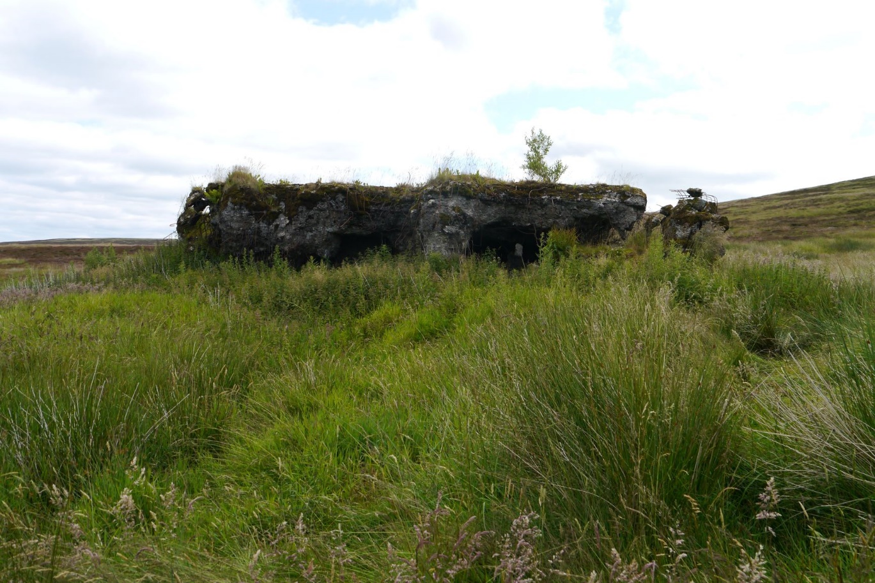
Figure 8 The Atlantic Wall, the most obvious of the military remains on the muir (photo John G Harrison).

Drainage, Forestry, Wind Farms etc.
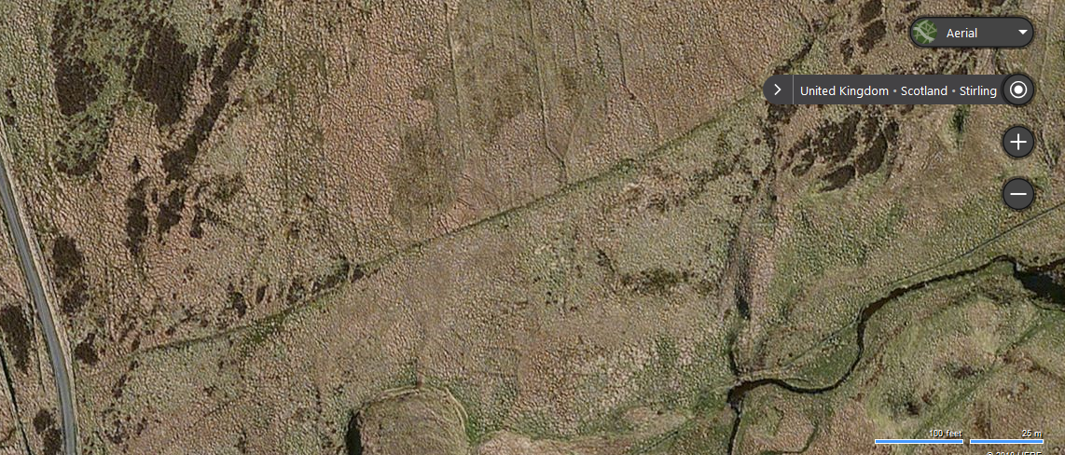
Figure 9 Straight, machine-cut, modern drains have a major impact on ecology (Bing Aerial).
Whilst simple, open ditches were probably a feature of the seventeenth and eighteenth century fields adjacent to the muir (and of any new intakes created then) deeper drainage is likely to be later. One phase, often undertaken in the nineteenth century, was to manually dig what were called Sheep Drains to improve pasture. Survey would be needed to know how far (and where) they were dug in this area and scientific studies to determine what ecological impact they had. Aerial photography (including Bing Aerial) shows extensive, machine-cut drains, likely to be twentieth century [Figure 8]. Some drainage was done in preparation for forestry planting eg to the west of the Sheriffmuir Inn, though some of the trees have been felled in the last few years. The areas of planting on Black Hill of Balhaldie, for example, will also have been drained prior to planting. Such planting has profound and certainly enduring impacts on the archaeology, biology and appearance of the land, impacts which are enduring or irreversible.
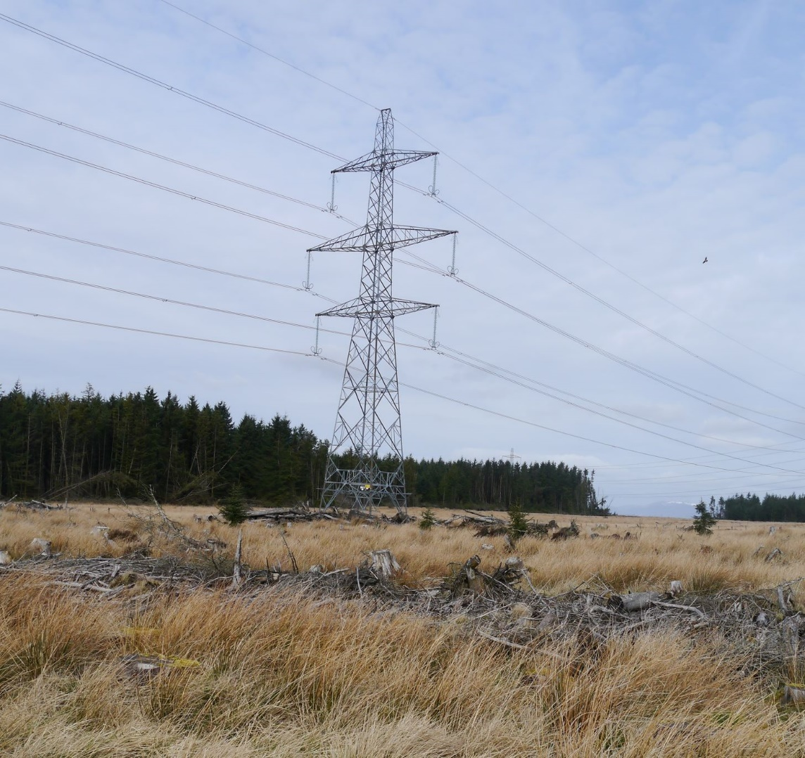
Figure 10 Felled forestry and Beauly-Denny power line (photo John G Harrison)
The twenty first century has seen two different major developments in the vicinity. The Beauly-Denny power line crosses the lower part of the core area, between the Sheriffmuir Inn and the MacRae Monument (some of the forestry felling, just noted, was undertaken in connection with installation of the access road, pylons and cables) [Figure 10]. Secondly, the 'Jerah Forest', ploughed and planted (2014-5) on land adjacent to the core area, indeed, in places just a few meters away across the Auld Wharry Burn whilst some of the planting on the Kippendavie Estate (2017-8) is within the designated battle site. These two processes (power line and tree planting) are not unconnected as both are partly driven by Scottish Government priorities to mitigate climate change (albeit both are also commercial schemes involving major capital expenditure and technical sophistication, Jerah the largest commercial forestry development in many years). So, as in earlier centuries, the muir is impacted by wider technical, political and economic factors and these make it close to inevitable that there will be further proposals in the locality as there are across Scotland - indeed, there is already talk of tree planting on Glentye Hill, above the core area. Such developments are within a long tradition of change. On the other hand, the rate, scale and depth of these industrial schemes far outstrips anything which has happened in the past and will have an impact likely to endure for many centuries (Pollard, for example, notes the destructive impact of modern forestry on underlying archaeology). Even the 'mitigation' (including access paths, drystone dykes & parking areas) impact on existing ecology, archaeology and landscapes; better paths, admirable in themselves, bring more people and erosion (whilst many visitors will arrive by car, with a consequent carbon footprint); any carbon sequestration will be over decades, rather than the needful centuries or millennia. ''Mitigation' at Jerah includes leaving a 'halo' unplanted around known archaeological sites but, especially as the trees grow up, this inevitably separates them from their landscape context. Paradoxically, the fact that much of the Jerah site had been surveyed and studied in detail, indeed, was one of the best-understood landscapes in Scotland, was argued as a factor in favour of the development (RCAHMS, 2001).

References
Adams, I.H. 1971. Directory of Former Scottish Commonties, Scottish Record Society, Edinburgh.
Atkinson, John A., with Chris Dalglish, Nicholas T Dixon, Michael Donnelly, John G Harrison, Olivia Lelong and Gavin MacGregor (2016) Ben Lawers: An Archaeological Landscape in Time; Results from the Ben Lawers Historic Landscape Project, 1996–2005, Scottish Archaeological Internet Reports, 62 http://archaeologydataservice.ac.uk/archives/view/sair/contents.cfm?vol=62
Barrow, G. W. S, 1973. The Kingdom of the Scots, Edward Arnold, London.
Barty, A, B, 1944. The History of Dunblane, Mackay, Stirling.
Cowley, D.C., Guy, J.A. & Henderson, D.M, 1999. The Sheriffmuir Atlantic Wall: An Archaeological Survey on part of the Whitestone Military Range, Forth Naturalist and Historian, 22, 107-116.
Dixon, P. 2018, 'What do we really know about transhumance in medieval Scotland? in Costello, E and Svensson, E (eds.), Historical archaeologies of transhumance across Europe, Routledge, London.
Fraser, W., 1858. The Stirlings of Keir and their Family Papers, Edinburgh.
Haldane, A.R.B., 1973. The Drove Roads of Scotland, David & Charles, Newton Abbot.
Harrison, J. G., 1998, Glendevon, A Report for the Royal Commission on the Ancient and Historical Monuments of Scotland, (National Record, MS 1155/2).
Harrison, J.G., 2012. Eddleston Water; Historical Change in Context, A Report for the Tweed Forum.
Harrison, J.G., In Press. The Stirling Area 1560-1750, in, Agriculture, Economy and Society in Early Modern Scotland, edited by Harriet Cornell, Julian Goodare and Alan R. MacDonald.
Historic Environment Scotland, [HES] Inventory of Battlefields, http://portal.historicenvironment.scot/designation/BTL17
HES - Canmore Website - https://canmore.org.uk/
Inglis, W., 2005. The Battle of Sheriffmuir, Stirling Libraries Community Services.
McKim, A., 2003. The Wallace: Selections (Books 7-12), https://d.lib.rochester.edu/teams/text/mckim-wallace-selections-books-7-12
Mair, C., 2018. History of Bridge of Allan, Dr. Welsh Trust, Bridge of Allan.
Mitchell, J. 1997. Old Limestone Workings in Glen Tye and their Associated Flora, Forth Naturalist and Historian, 20, 3-5.
Monteath, J. 1887. Dunblane Traditions, Miller, Glasgow.
Neville, C. 2005. Native Lordship in Medieval Scotland; The Earldoms of Strathearn and Lennox, c. 1140-1365, Four Courts Press, Dublin.
Pollard, T., 2015. Mosses and Musket balls: pinpointing the Sheriffmuir Battle Field, Forth Naturalist and Historian, 38, 131-143.
[RMS] Register of the Great Seal of Scotland, various dates, Edinburgh.
[RCAHMS [Royal Commission on the Ancient and Historical Monuments of Scotland, 2001. Well Sheltered and Watered; Menstrie Glen, A Farming Landscape Near Stirling, Edinburgh.
Watson, Angus, 2002. 'Place-names, Land and Lordship in the Medieval Earldom of Strathearn', Unpublished Ph D, University of St Andrews (http://hdl.handle.net/10023/11331).
Wills, V, 1973. Reports on the Annexed Estates 1755-1769, HMSO, Edinburgh.

